**CPSC 471 - Database Management Systems**

**Functional Model**

Desmarais, Jesse (00292117)

Pordanesh, Saman (30127440)

Welch, Quenten (30054505)

Group 61

March 12, 2023

**Use-Case Diagram**

[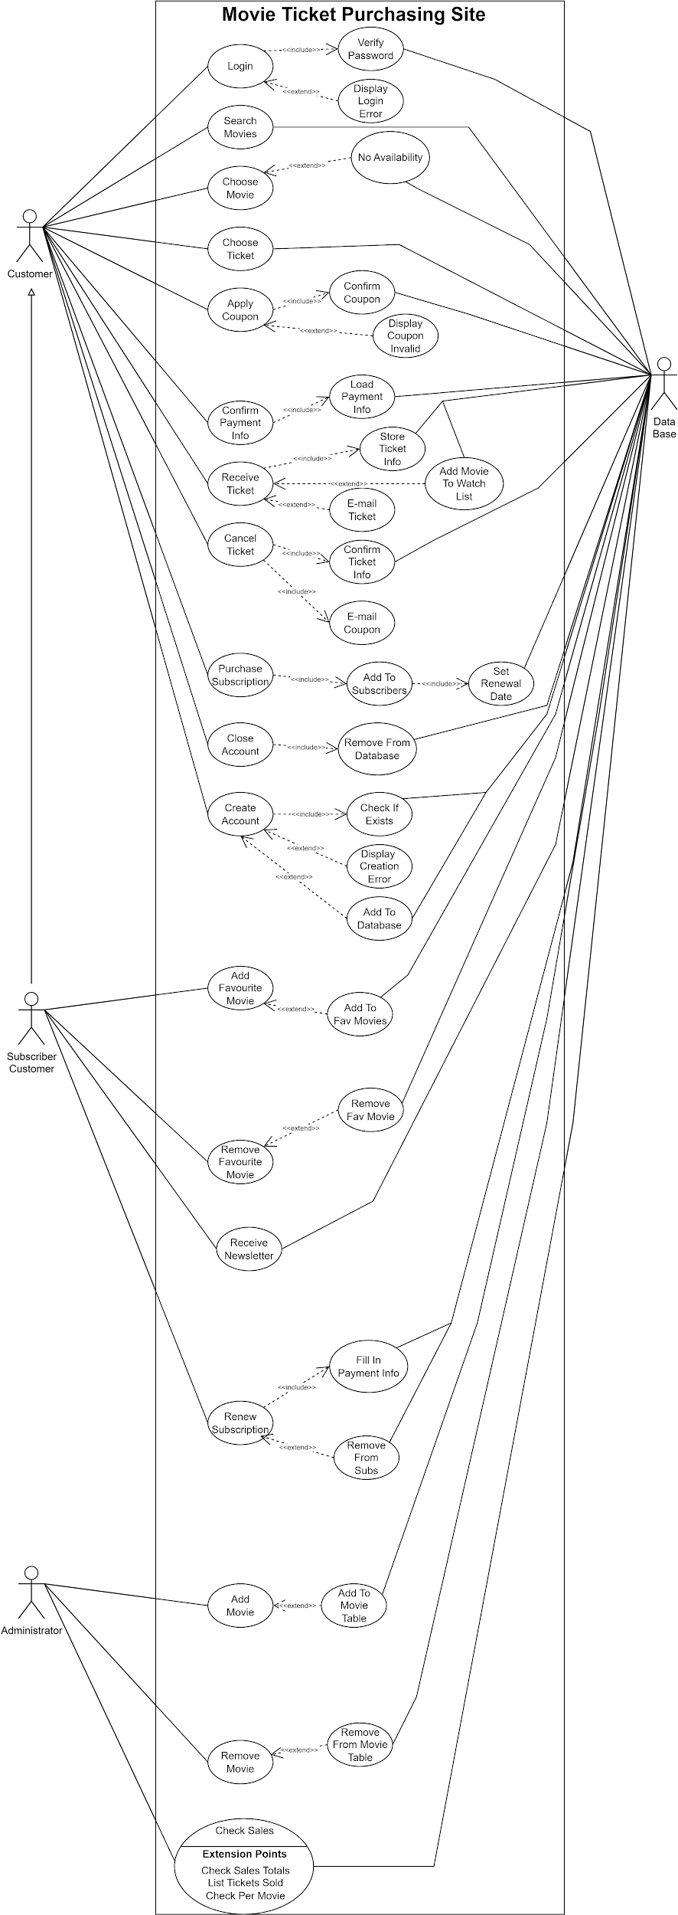](https://app.diagrams.net/?page-id=dSf-gxv7yXBHyazLbG9A&scale=auto#G1tgq90J6chLIdXXQfulm1rfEaJKt9EJOO)

This is hard to see, so please visit this link to be able to view a higher quality version:

<https://viewer.diagrams.net/?tags=%7B%7D&highlight=0000ff&edit=_blank&layers=1&nav=1&title=Use_Case_Diagram_v2.drawio#Uhttps%3A%2F%2Fdrive.google.com%2Fuc%3Fid%3D1tgq90J6chLIdXXQfulm1rfEaJKt9EJOO%26export%3Ddownload>

**Sequence Diagrams**

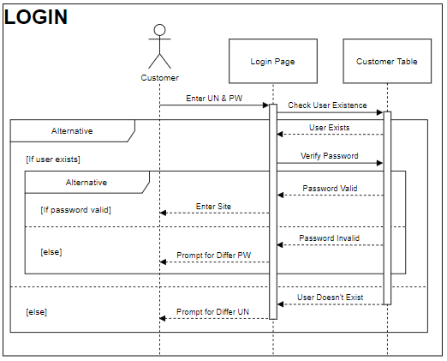

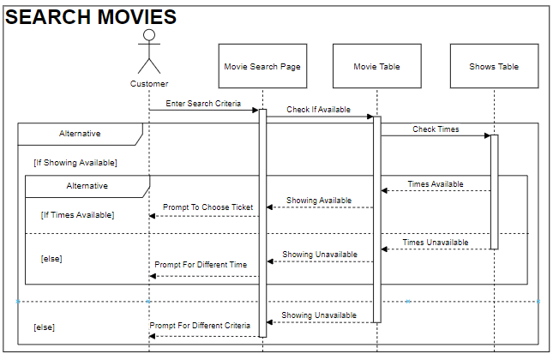

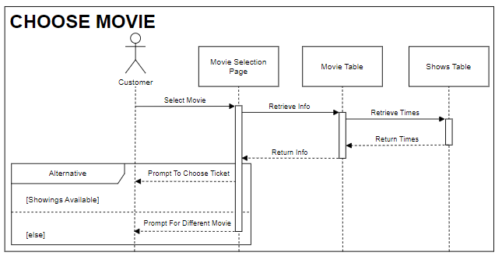

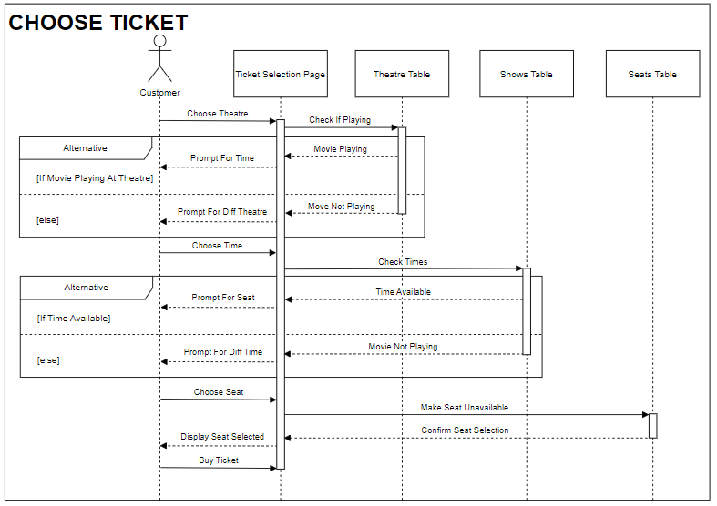

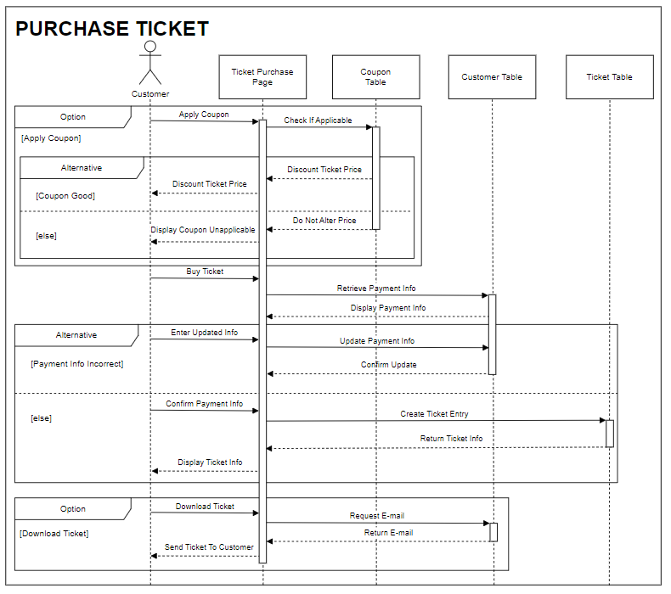

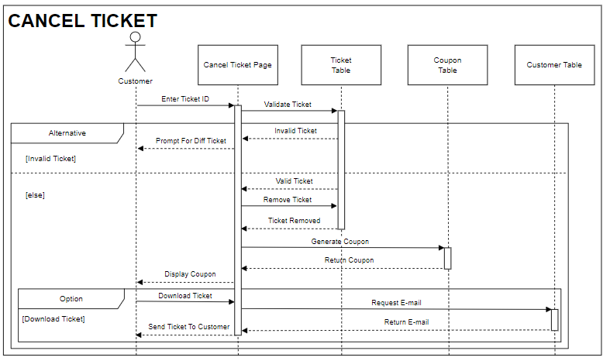

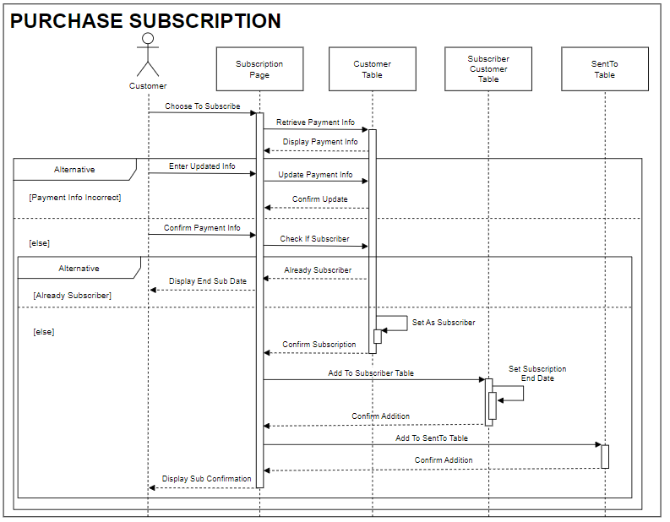

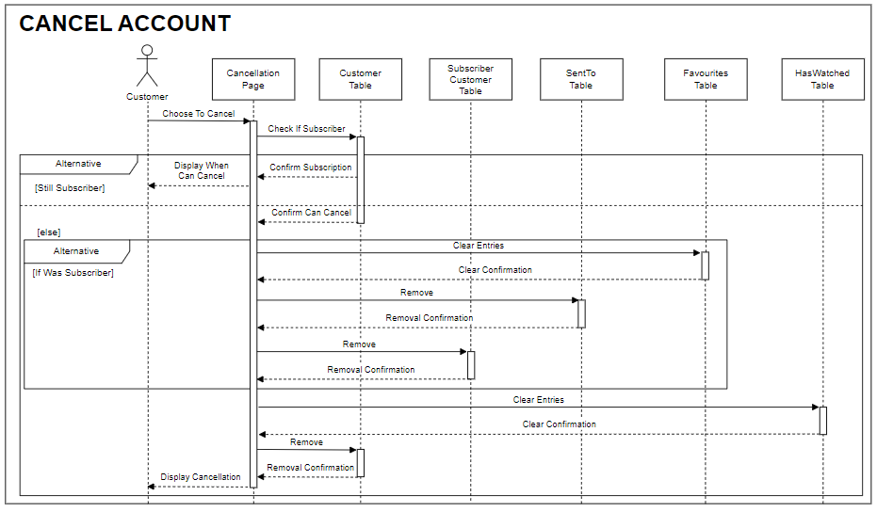

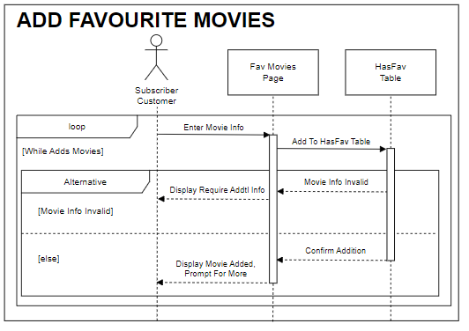

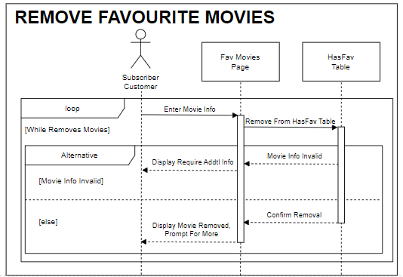

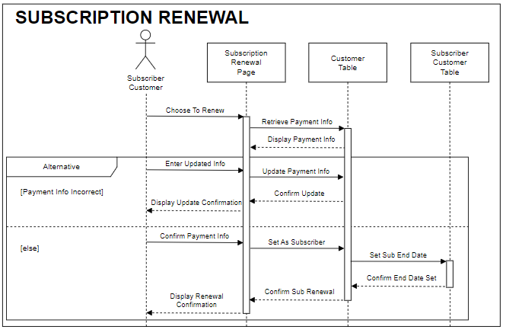

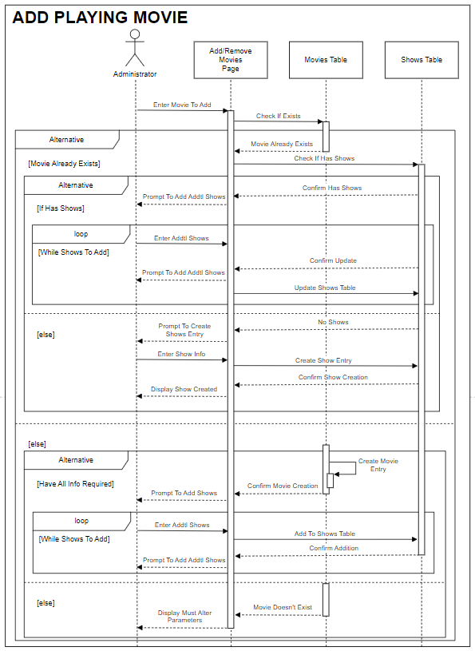

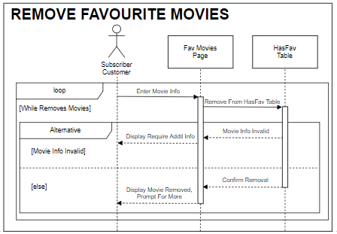

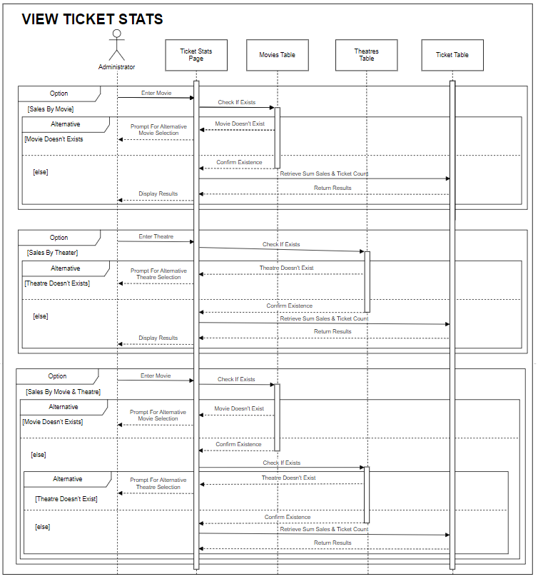

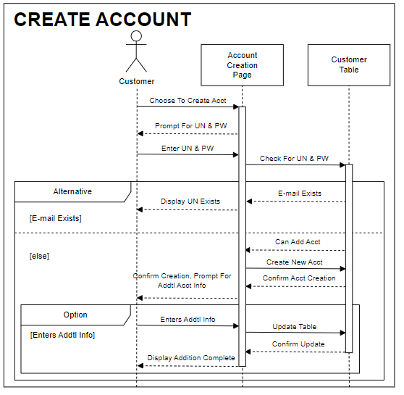

This can be hard to see, so please visit this link to be able to view a higher quality version:

<https://viewer.diagrams.net/?tags=%7B%7D&highlight=0000ff&edit=_blank&layers=1&nav=1&title=Sequence_Diagram_v2.drawio#Uhttps%3A%2F%2Fdrive.google.com%2Fuc%3Fid%3D1zIXKUhzWz28HHbS7iw4I_VkL6Bxes3gJ%26export%3Ddownload>